Date: 22/12/2025
Lab Practical #04:
Develop mobile or web screen using the tools listed below.

Practical Assignment #04:
Use Basic Tools using Dark Mode with Selection Colors, Gradients, Creating Backgrounds.

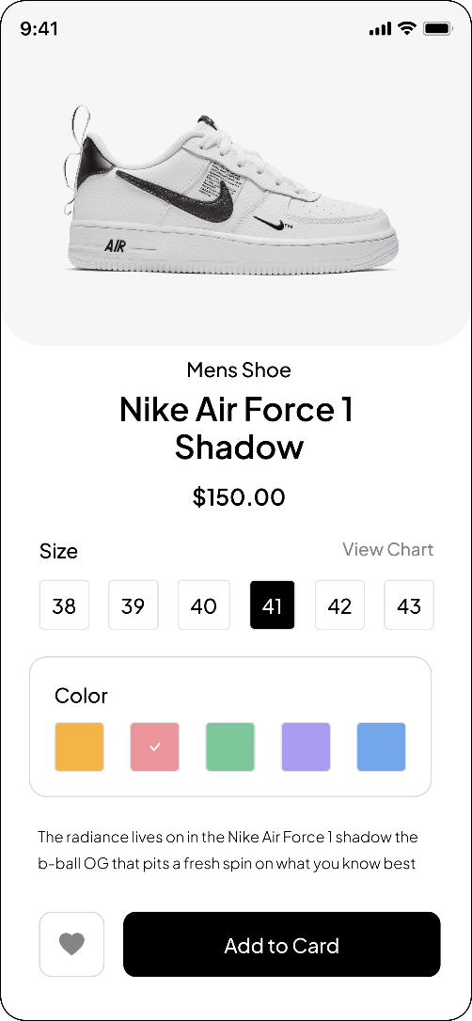
Description:

Light – Screen

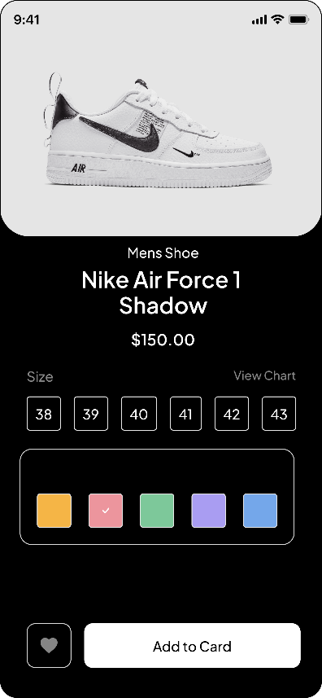
Dark- Screen
Date: 22/12/2025

